**DATA ANALYTICS WITH TABLEAU**

ASSIGNMENT-1

1. BAR CHART:-

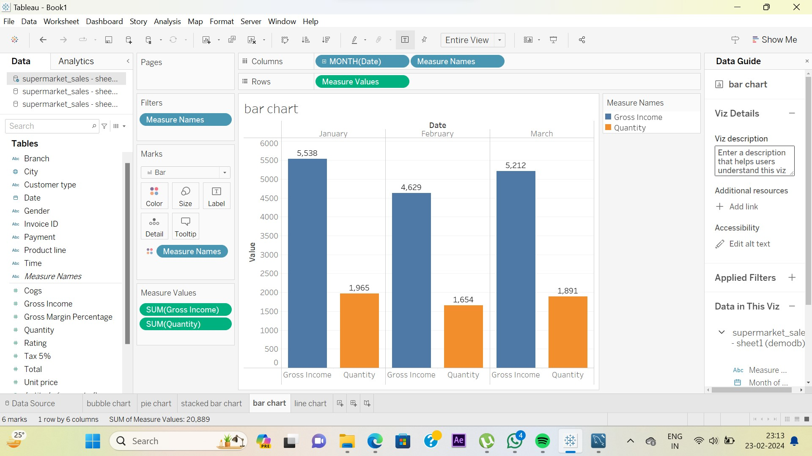

1. PIE CHART:-

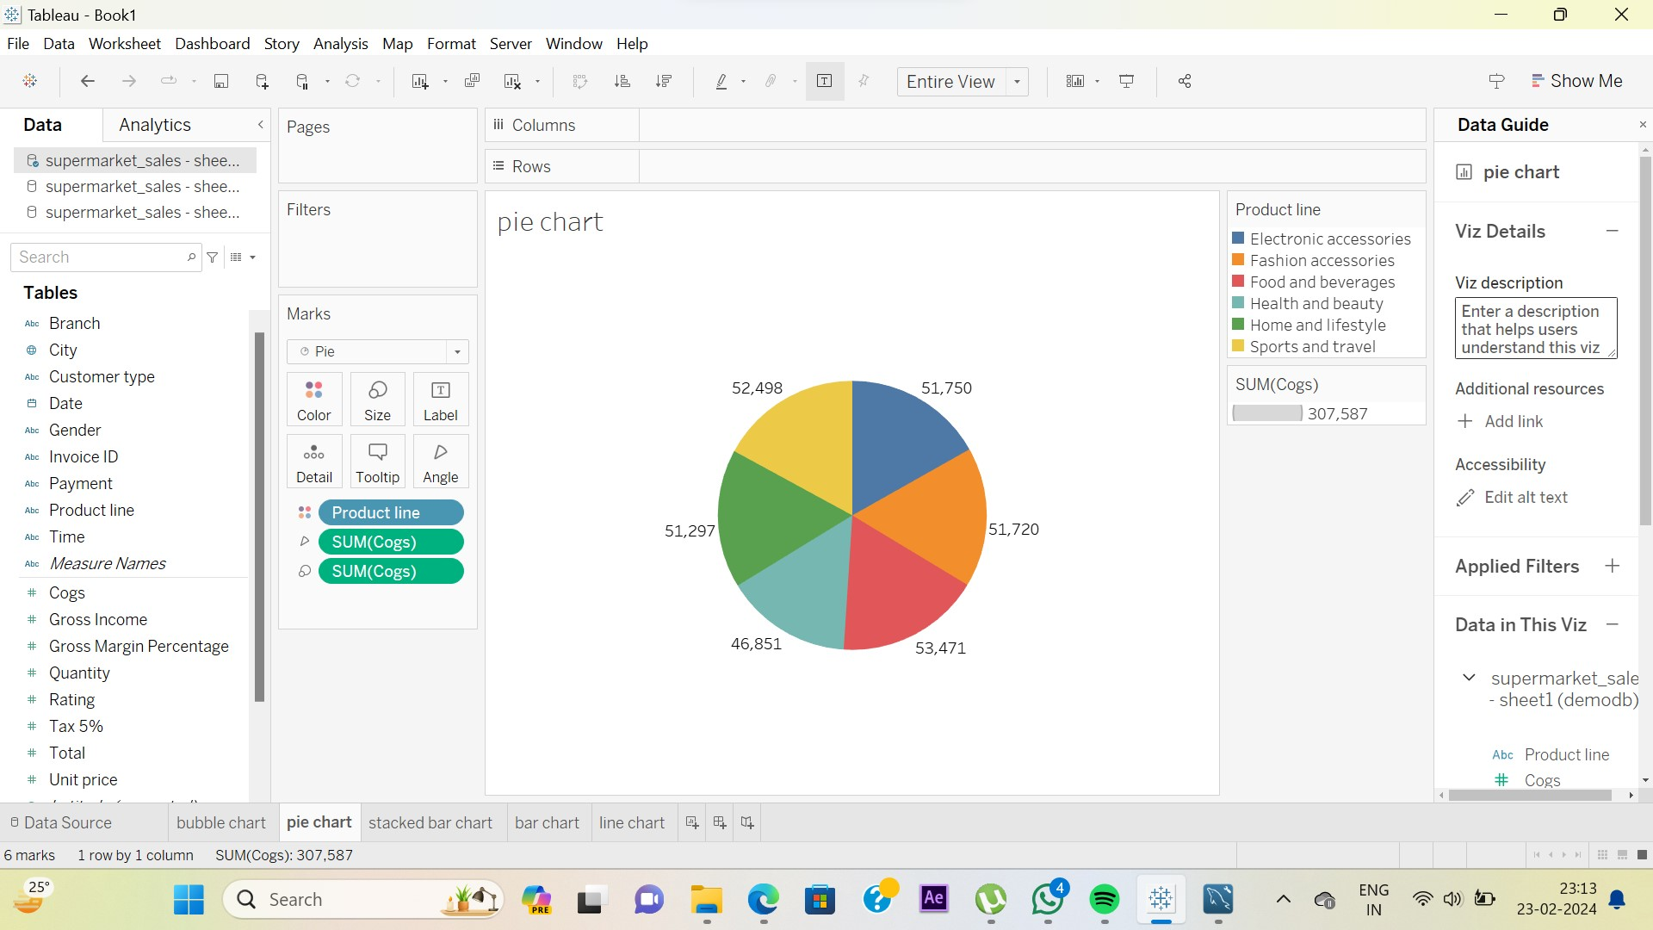

1. STACKED BAR CHART:-

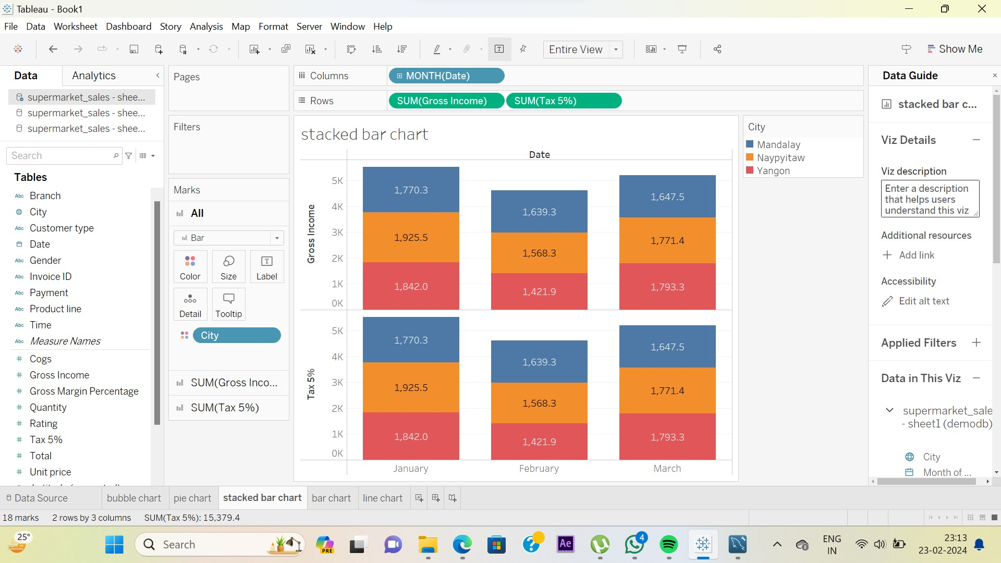

1. LINE CHART:-

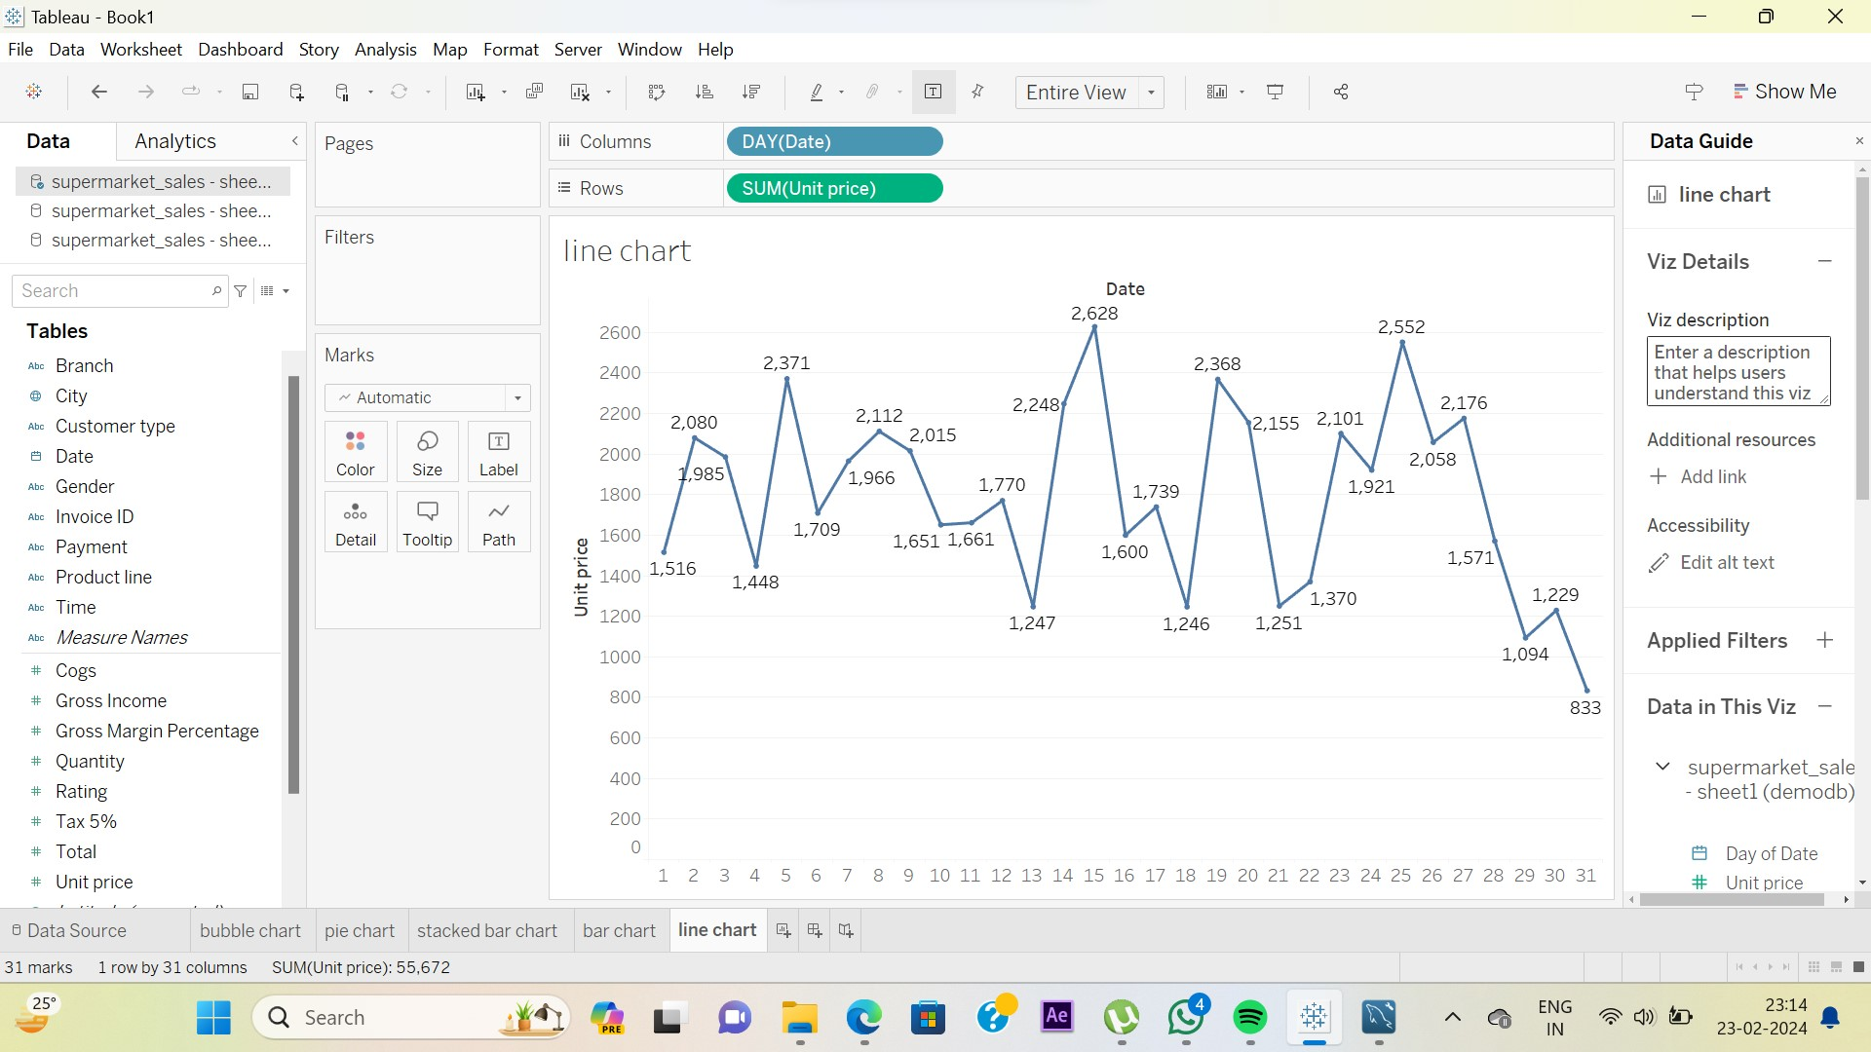

1. BUBBLE CHART:-

